CrowdClear: Command Under Pressure
Oct 10, 2026 · @Colin

The project
CrowdClear is an evacuation training game for venue staff, built in 36 hours. A player spots congestion, opens an alternative exit, and redirects people. After the drill, a review shows their decisions and results, and the player can change one decision and watch both outcomes play out together.
The first version contains one stadium lobby, three exits, about 30 simple crowd figures, and a 90-second scenario. These are build targets, not measured performance claims.
What changed in this revision
- Breathing sensing (Presage) is now a stretch goal with a go/no-go decision at hour 2 and a build slot near the end.
- Crowd routing uses one flow field per exit instead of a path search per agent.
- Session storage moves into the first half; deployment happens in hour 1.
- Replay runs entirely in the browser; the server only stores and returns data.
- The comparison becomes a ghost replay: the original crowd faded, the alternative solid, running at the same time.
- Judging targets narrow to three primary categories.

The tools
The stack stays the same; only Presage changes status, from optional core feature to stretch goal.
Tool | What it does | Status
A-Frame | 3D scene, camera, controller and mouse pointers, positional audio, WebXR. Built on Three.js. | Core
HTML + CSS | Start screen, instructions, post-drill review. | Core
Plain JavaScript | Crowd simulation, flow fields, interactions, scoring, replay. | Core
Node.js + Express | Serves the frontend; stores and returns sessions, commands, results. | Core
Neon Postgres | Stores runs, commands, results, and any measurements. | Core
Render | Hosts the Express app at an HTTPS address, which WebXR requires. | Core
Prepared audio clips | Alarms, announcements, ambient sound. ElevenLabs can pre-generate the spoken clips. | Core
Presage SmartSpectra | Breathing rate from a webcam through a local Node helper. | Stretch: only if the hour-2 check passes
References: A-Frame docs, Presage Node SDK, Render Express deployment.

How the parts connect
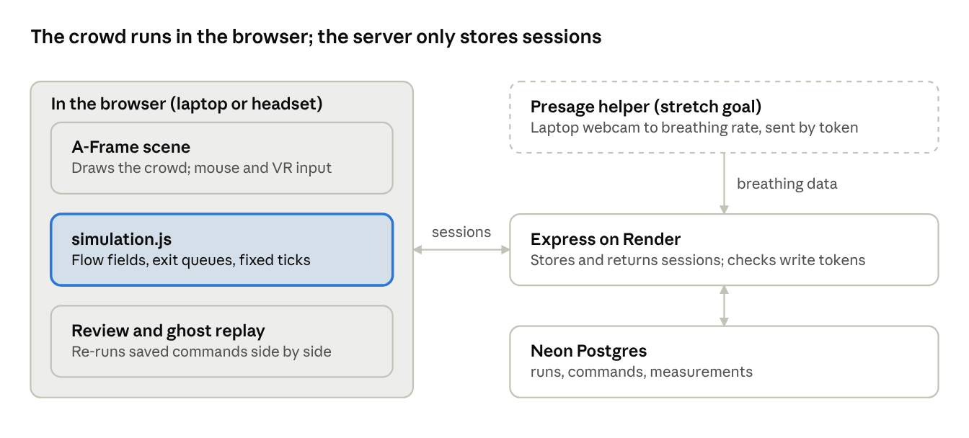
architecture · browser, server, database, optional helper
The simulation and replay run entirely in the browser; Express only saves and returns sessions, so a slow network never changes crowd behavior. The optional helper sends derived breathing values to Express; the server never touches the webcam.

Build steps
The order puts everything risky or foundational first, so the last third of the event is polish, not rescue.
- Deploy first, in hour 1. Push a bare Express server and an A-Frame example scene to Render. Open the published HTTPS URL on the actual headset: enter VR, select an object, play audio. Confirm mouse selection on the laptop. Connect Neon and write one test row. From here on, every merge is tested on the live URL.
  - WebXR needs HTTPS, so the headset cannot test against plain localhost anyway.
  - Check Render's current free-tier behavior. Free services have historically spun down when idle, which makes the first load slow.
- Run the Presage go/no-go (hours 0–2, one person). Try the SDK sample on the demo laptop with the real lighting. If it doesn't produce usable breathing readings by hour 2, drop sensing and the Encompass target. No second attempt.
- Create one readable lobby. A floor plane, box walls, three clearly marked exits, and simple crowd figures. The player stands at a fixed command position with a clear view of all three exits.
- Implement crowd routing with flow fields. Divide the walkable floor into equal grid cells. For each open exit, run one breadth-first search outward from the exit cells and store, in every cell, the next cell toward that exit.
  - Each agent reads the field of its assigned exit and steps to the next cell, keeping basic spacing.
  - Exits release agents at a fixed rate, so queues form naturally.
  - When an exit opens or closes, recompute only the affected fields (three searches over a small grid are instant).
  - A cell with no route stores nothing; an agent standing there waits instead of walking through walls.
  - Visit neighbor cells in a fixed order so ties always break the same way. This keeps replay reproducible.
- Add two player actions. Open an available alternative exit, and assign a marked crowd group to a different open exit using preset directional markers. Route desktop clicks and VR controller selection to the same action handlers. Put essential VR instructions and controls inside the 3D scene.
- Save sessions to Neon. This is small, so it lands in the first half. Store the initial scene state, simulation version, each command with its tick and order, and final results. Batch uploads without blocking gameplay, and give every event a stable ID so a retried upload never duplicates it.
- Create the emergency round. At a fixed tick in the 90-second drill, an incident blocks the familiar exit. The crowd queues, and the player must redirect it. The hazard schedule never changes; only the player's commands do.
- Build the review and ghost replay. Show people evacuated before the deadline, maximum queue size, and time to redirect the blocked stream, with commands on one timeline.
  - The player changes one command; the browser re-runs both versions from the same initial state and hazard schedule.
  - Draw the original crowd as faded figures and the alternative as solid ones, in the same scene, at the same tick. Show both sets of results side by side and label the alternative a simulated outcome.
  - Re-simulate the original from its saved commands rather than storing positions. If its final result matches the saved one, you have proof of determinism to show judges.
  - Use fixed simulation ticks; frame rate must never change crowd behavior.
- Add sound and visual clarity. Prepared announcements tied to scenario events, environmental sounds at their sources, radio speech at the player's radio. Add captions, an accessible pause, and signage that uses symbols and text as well as color.
- Add breathing feedback, only if step 2 passed. Desktop mode: the player sits facing the webcam for a 30-second warm-up and baseline, then sees breathing rate and status during the drill. VR mode: measure before and after the drill only, since the headset hides the face. Missing or stale readings display as unavailable. Sensing never affects the score or blocks emergency controls.
Freeze features at hour 28. Everything after that is fixing, rehearsal, and sleep.

Project layout
The simulation lives in one file with no rendering code, so the live drill, the replay, and the ghost all call the same function.
crowdclear/
server.js Express: serve files, save and load sessions
schema.sql Neon tables
public/
index.html A-Frame scene and ordinary interface
styles.css Menus and review styling
simulation.js Grid, flow fields, queues, scoring; step(state, commands) only
game.js Input, scenario events, drawing agents each frame
review.js Timeline, command editing, ghost replay
assets/ Models and prepared audio
sensor.js Stretch: local Presage helper
Table | Holds | Key detail
runs | Initial state, simulation version, final results | Results let replay check itself for determinism
commands | Run ID, tick, order, action, target | Stable event ID makes retries safe
measurements | Run ID, timestamp, breathing rate, quality | Only created if sensing ships; derived values, never footage
Keep the Neon connection string in Render environment variables. Validate API input, and require a per-session token for any write.

Judging targets
Three primary targets that tell one story: a serious game, with saved sessions that make the replay possible. Sponsor rooms each need a teammate present during judging, so every extra room costs demo coverage.
Target | Priority | Evidence to show
Full Sail | Primary | A serious training scenario with working flow-field routing and meaningful intervention
Neon | Primary | A saved drill reopened from the database and replayed as a ghost comparison
Best Game | Primary | A complete loop with clear consequences; Best Overall is considered automatically
Encompass | Only if sensing ships | Real breathing readings with visible quality, used in feedback
Figma / Adobe | Only if a teammate designs in Figma | Consistent signage, legible controls, a designed review screen
Confirm opt-in deadlines and room assignments for each sponsor challenge at the opening ceremony.

Build schedule
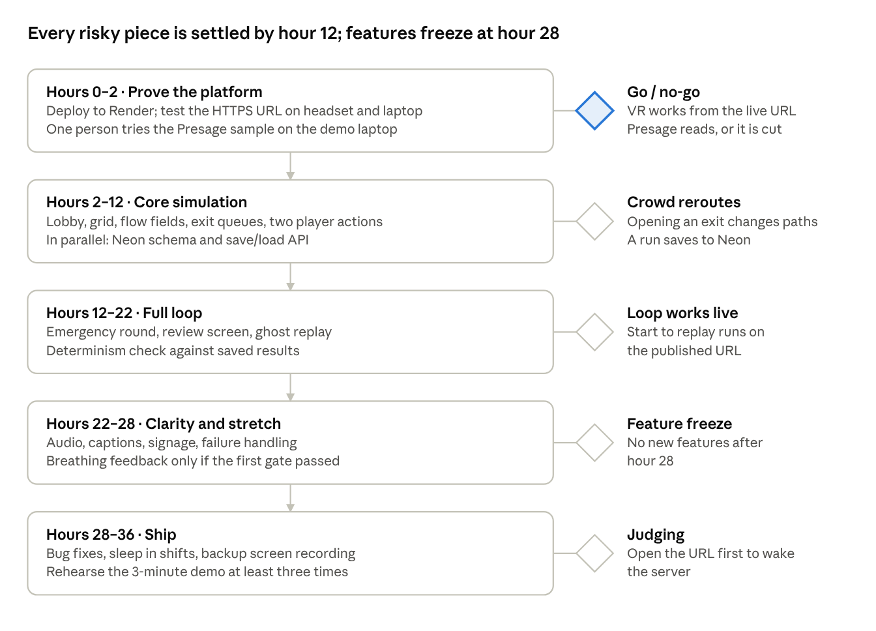
build schedule · 5 phases, 5 gates
If a gate isn't met on time, cut scope from the next phase rather than pushing the gate back. Storage now lands in hours 2–12, which frees hours 12–22 for the round and replay.

Completion checks
- ☐ The published HTTPS URL enters VR on the actual headset and works with a mouse on the laptop.
- ☐ A blocked exit cannot be traversed; agents with no route wait.
- ☐ Opening an alternative exit visibly changes crowd movement within a few seconds.
- ☐ Re-simulating a saved run reproduces its saved final result exactly.
- ☐ Changing one command keeps every other input and the hazard schedule identical.
- ☐ Ghost and alternative crowds run together without the frame rate dropping noticeably on the headset.
- ☐ Failed saves never display as successful; retried uploads don't duplicate events.
- ☐ If sensing shipped: stale or invalid readings display as unavailable.
- ☐ A full round runs start to reset on the demo hardware, three times in a row.

Judge demonstration
Aim for about three minutes, with the judge holding the controls.
- Problem (20 seconds). Venue staff rarely rehearse evacuations, and real drills are expensive and disruptive.
- Drill (90 seconds). The familiar exit is blocked and a queue builds. The judge opens an alternative exit and redirects a crowd group.
- Review (30 seconds). Show evacuated count, maximum queue, and time to redirect, with commands on the timeline.
- Ghost replay (40 seconds). Change one decision, for example redirecting 15 seconds earlier. Play both together: faded original, solid alternative, results side by side.
For technical questions, show the flow-field grid overlay, explain how the saved run re-simulates to the same result, and how sessions are stored in Neon.
Open the published URL a few minutes before judging so the server is awake. Keep a screen recording of a full round as a backup in case the venue Wi-Fi fails.

Known limitations
- Not yet device-tested. Headset compatibility is confirmed in hour 1; sensing reliability at hour 2.
- Evacuation results are simulation outputs, not validated real-world predictions.
- Replay reproducibility is guaranteed on the same browser and code version. Results may differ slightly across browsers, so run replays on the device that recorded them.
- Breathing sensing, if it ships, needs a still player with face and chest visible. Continuous sensing during VR is out of scope.

